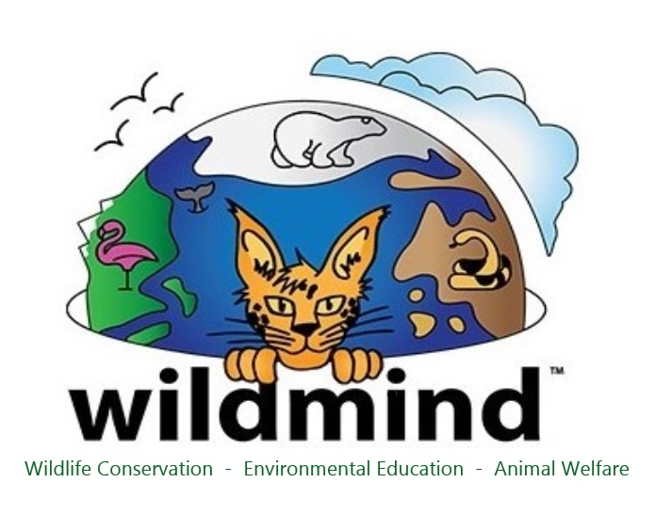
Position Title: ---- Educator/Handler
Organization: ---- Conservation Earth/Wildmind (previously Wildlife Associates) in Half Moon Bay, CA (SF Bay Area)

As we continue to expand the variety and scope of programs that we offer, we are seeking a full-time Wildlife Educator/Handler with a passion for teaching and experience working with a wide variety of non-releasable wild animals.

We are looking for a motivated, skilled, adaptable and energetic individual. This person must have strong and positive interpersonal skills, be motivated plus have the desire and capacity to work as part of our dedicated team. The candidate must be able to take and follow directions as well as demonstrate initiative and responsibility. Proven public speaking, communication and teaching ability are essential. This person does not have to be funny but definitely has to be fun!

This applicant will learn our teaching and training methods to participate in presenting engaging and educational environmental science assemblies and various kinds of classes while safely and professionally handling wild animals for these programs. This person will also be involved in the ongoing tasks related to providing daily husbandry, training, socializing and enrichment for the roughly 50 animals in our care.

For this position, a minimum of two years of full-time previous handling experience with outreach ambassadors as well as presentation experience- to both large and small audiences- is needed. Experience teaching in formal or informal education settings is also valued.

Valid driver’s license with an acceptable safety record as well as ability to pass a background check and drug test, throughout the term of employment, is required.

This is a full-time salaried position with benefits. Compensation is commensurate with experience. Schedule will vary based on programming. This position will begin as soon as the right candidate is hired.

Send cover letter and resume with three (3) verifiable references to: michele@wildmindscience.org

